1. Search Page  
   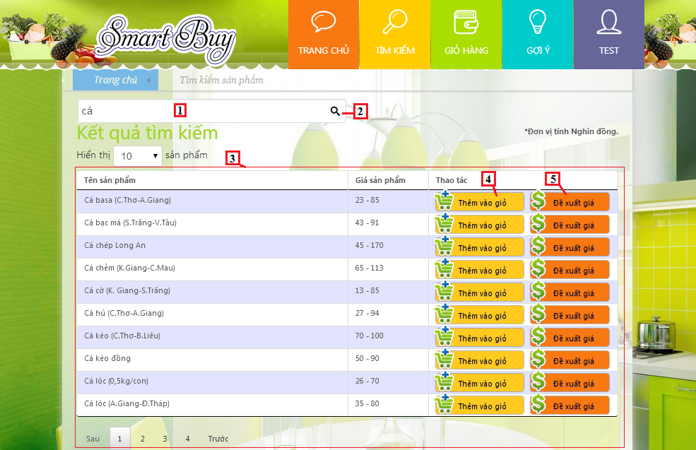

**Fields**

|  |  |  |  |  |  |  |  |
| --- | --- | --- | --- | --- | --- | --- | --- |
| **No** | **Field Name** | **Description** | **Read only** | **Mandatory** | **Control Type** | **Data Type** | **Length** |
| 2 | Product name | Fill product name | No | No | Textbox | String | N/A |
| 3 | Product list | Show list product | Yes | Yes | Table list view | N/A | N/A |

**Button/ Hyperlink**

|  |  |  |  |  |
| --- | --- | --- | --- | --- |
| **No** | **Function** | **Description** | **Validation** | **Outcome** |
| 1 | Search | Click to search | N/A | N/A |
| 4 | Add to cart | Add product to cart | N/A | N/A |
| 5 | Propose price | Click to propose price | N/A | Show pop-up propose product price |

**Product List includes**

|  |  |  |  |  |  |
| --- | --- | --- | --- | --- | --- |
| **Field Name** | **Description** | **Read only** | **Control Type** | **Data Type** | **Length** |
| Product name | Show product name | Yes | Textview | String | N/A |
| Price | Show product price | Yes | Textview | Integer | N/A |
| Action | Action for product | N/A | Button | N/A | N/A |

2. Propose Price

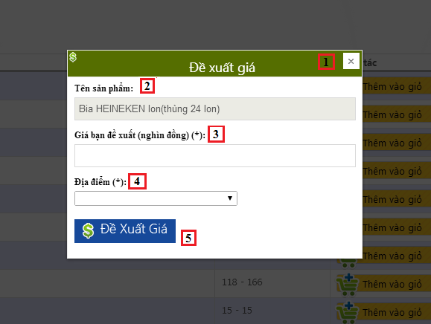

**Fields**

|  |  |  |  |  |  |  |  |
| --- | --- | --- | --- | --- | --- | --- | --- |
| **No** | **Field Name** | **Description** | **Read only** | **Mandatory** | **Control Type** | **Data Type** | **Length** |
| 1 | Propose Product price | Fill propose product price. | N/A | N/A | Label | String | N/A |
| 2 | Propose Product price | Fill product name | Yes | N/A | Textbox | String | N/A |
| 3 | Propose product price | Fill product price | No | Yes | Textbox | Integer | 1-10000 |
| 4 | Market name | Select market name | No | Yes | Dropdown list | String | N/A |

**Button/ Hyperlink**

|  |  |  |  |  |
| --- | --- | --- | --- | --- |
| **No** | **Function** | **Description** | **Validation** | **Outcome** |
| 5 | Propose price | Click to propose price | N/A | Close propose product price pop-up |

3. View cart

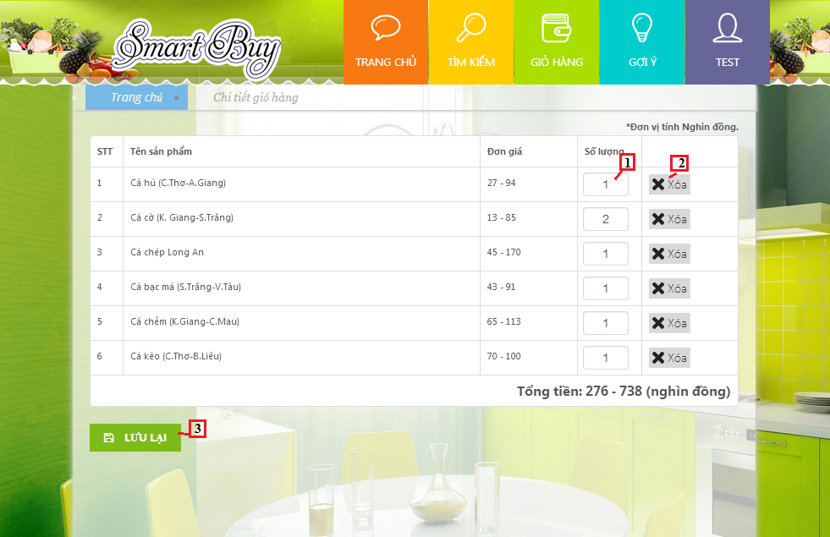

**Fields**

|  |  |  |  |  |  |  |  |
| --- | --- | --- | --- | --- | --- | --- | --- |
| **No** | **Field Name** | **Description** | **Read only** | **Mandatory** | **Control Type** | **Data Type** | **Length** |
| 1 | Quantity product | Fill product quantity | No | N/A | Textbox | Integer | [1-10] |

**Button/ Hyperlink**

|  |  |  |  |  |
| --- | --- | --- | --- | --- |
| **No** | **Function** | **Description** | **Validation** | **Outcome** |
| 2 | Delete | Click to remove product | N/A | N/A |
| 3 | Save | Save cart to history | N/A | Transfer to buying history |

4. Buying History

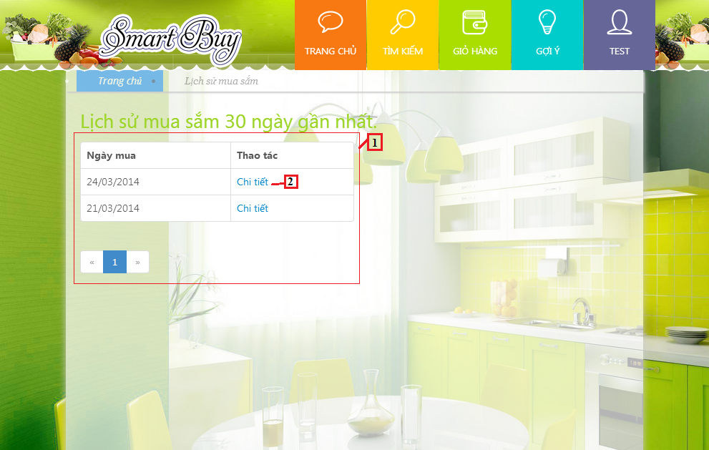

**Fields**

|  |  |  |  |  |  |  |  |
| --- | --- | --- | --- | --- | --- | --- | --- |
| **No** | **Field Name** | **Description** | **Read only** | **Mandatory** | **Control Type** | **Data Type** | **Length** |
| 1 | Buying history | Show list order history | No | No | Table list view | N/A | N/A |

**Button/ Hyperlink**

|  |  |  |  |  |
| --- | --- | --- | --- | --- |
| **No** | **Function** | **Description** | **Validation** | **Outcome** |
| 2 | Detail | Click to view order detail | N/A | Transfer to order detail page |

**Order History List includes**

|  |  |  |  |  |  |
| --- | --- | --- | --- | --- | --- |
| **Field Name** | **Description** | **Read only** | **Control Type** | **Data Type** | **Length** |
| Date | Show date order | Yes | Textview | String | N/A |
| Action | View order detail | N/A | Button | N/A | N/A |

5. Order detail

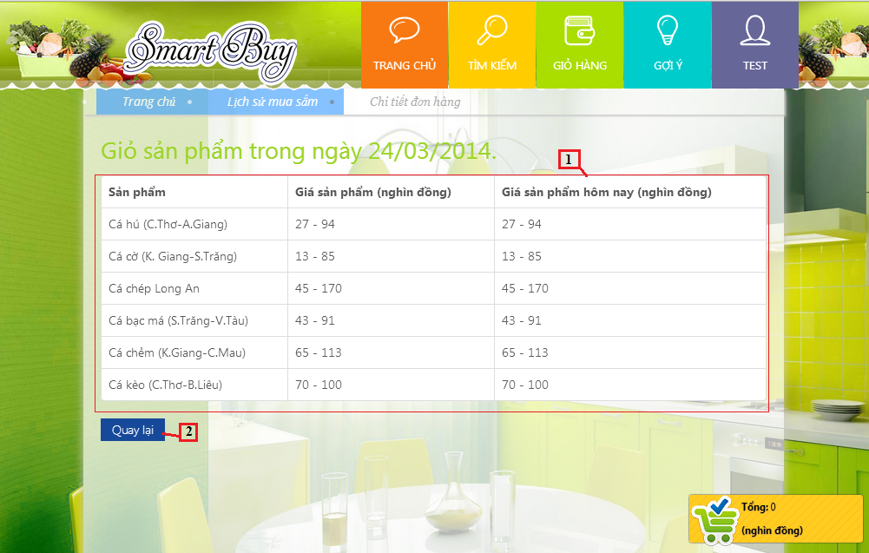

**Fields**

|  |  |  |  |  |  |  |  |
| --- | --- | --- | --- | --- | --- | --- | --- |
| **No** | **Field Name** | **Description** | **Read only** | **Mandatory** | **Control Type** | **Data Type** | **Length** |
| 1 | Order history | Show list product | No | No | Table list view | N/A | N/A |

**Button/ Hyperlink**

|  |  |  |  |  |
| --- | --- | --- | --- | --- |
| **No** | **Function** | **Description** | **Validation** | **Outcome** |
| 2 | Back | Back to order history page | N/A | Transfer to order history page |

**Order Product List includes**

|  |  |  |  |  |  |
| --- | --- | --- | --- | --- | --- |
| **Field Name** | **Description** | **Read only** | **Control Type** | **Data Type** | **Length** |
| Product name | Show product name | Yes | Textview | String | N/A |
| Product price | Show product price | Yes | Textview | Integer | N/A |
| Product current price | Show current price | Yes | Textview | Integer | N/A |

6. Suggest Route

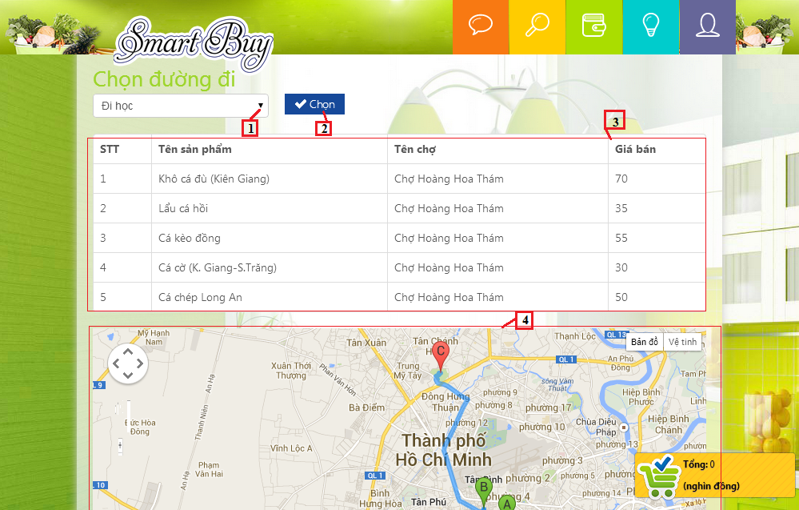

**Fields**

|  |  |  |  |  |  |  |  |
| --- | --- | --- | --- | --- | --- | --- | --- |
| **No** | **Field Name** | **Description** | **Read only** | **Mandatory** | **Control Type** | **Data Type** | **Length** |
| 1 | Route | Address name | Yes | No | Dropdown list | String | N/A |
| 3 | Order detail | Show list product | Yes | No | Table list view | N/A | N/A |
| 4 | Map | Show map suggest | Yes | No | Google map | N/A | N/A |

**Button/ Hyperlink**

|  |  |  |  |  |
| --- | --- | --- | --- | --- |
| **No** | **Function** | **Description** | **Validation** | **Outcome** |
| 2 | Suggest route | Click to view map | N/A | Show map |

**Order Detail includes**

|  |  |  |  |  |  |
| --- | --- | --- | --- | --- | --- |
| **Field Name** | **Description** | **Read only** | **Control Type** | **Data Type** | **Length** |
| STT | Number row | Yes | Textview | Integer | N/A |
| Product name | Show product name | Yes | Textview | String | N/A |
| Market name | Show market name | Yes | Textview | String | N/A |
| Product price | Show current price | Yes | Textview | Integer | N/A |

**7. User Profile**

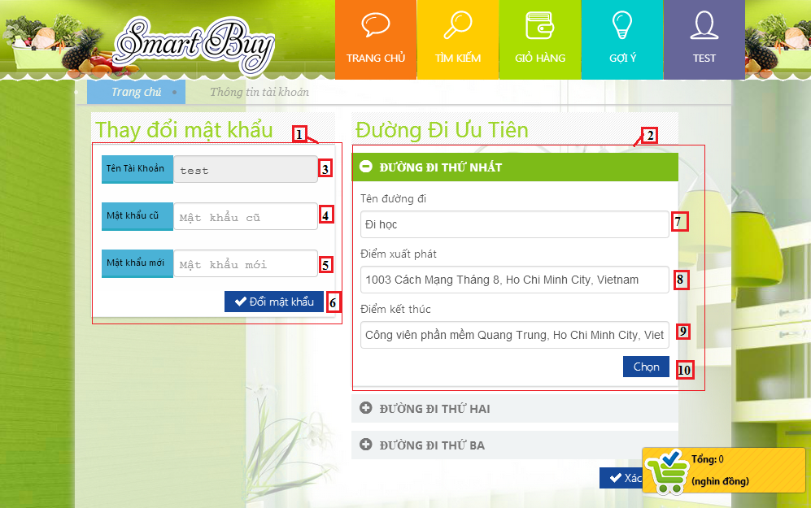

**Fields**

|  |  |  |  |  |  |  |  |
| --- | --- | --- | --- | --- | --- | --- | --- |
| **No** | **Field Name** | **Description** | **Read only** | **Mandatory** | **Control Type** | **Data Type** | **Length** |
| 1 | Change Password | N/A | N/A | N/A | Label | String | N/A |
| 2 | Route | Fill info detail of address | N/A | N/A | Label | String | N/A |
| 3 | Username | User’s name | Yes | N/A | Label | String | N/A |
| 4 | Old Password | Fill old password | No | Yes | Textbox | String | [6-100] |
| 5 | New password | Fill new password | No | Yes | Textbox | String | [6-100] |
| 7 | Route name | Route’s name | No | Yes | Textbox | String | N/A |
| 8 | Start route | Address of start route | No | Yes | Textbox | String | N/A |
| 9 | End route | Address of end route | No | Yes | Textbox | String | N/A |

**Button/ Hyperlink**

|  |  |  |  |  |
| --- | --- | --- | --- | --- |
| **No** | **Function** | **Description** | **Validation** | **Outcome** |
| 6 | Save | Save new password | Yes | N/A |
| 10 | Choose | Save info detail of address | Yes | N/A |